Positioning the BottomSheet above the Keyboard

By default, the BottomSheet will take up half the screen:

1. onPressed: () {
2. showModalBottomSheet(
3. context: context,
4. builder: (context) => AddTaskScreen(),
5. );
6. }

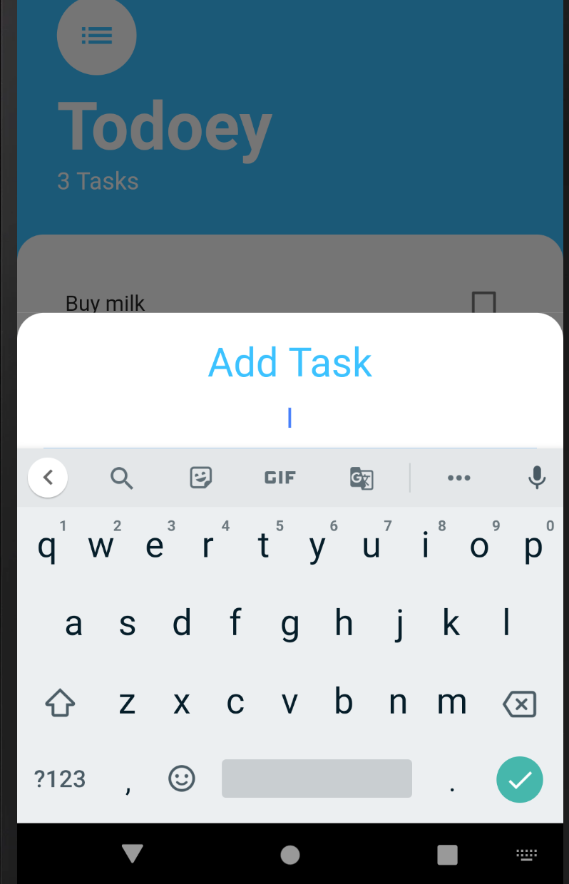

For certain screen sizes, this may mean the Add button is obscured. Setting the isScrolledControlled property to true you can make the modal take up the full screen:

1. onPressed: () {
2. showModalBottomSheet(
3. context: context,
4. isScrollControlled: true,
5. builder: (context) => AddTaskScreen(),
6. );
7. }

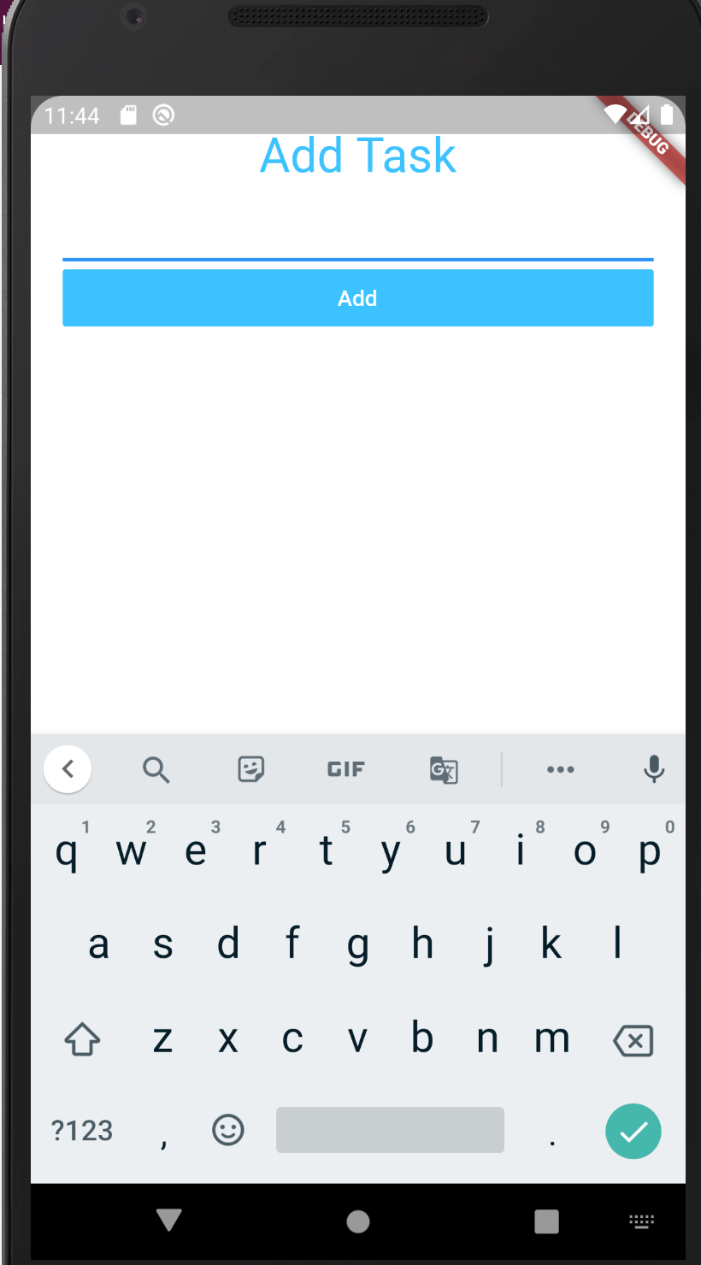

To have the AddTaskScreen sit just above the keyboard, you can wrap it inside a SingleChildScrollView, which determines the padding at the bottom using a [MediaQuery.](https://api.flutter.dev/flutter/widgets/MediaQuery-class.html" \t "https://www.udemy.com/course/flutter-bootcamp-with-dart/learn/lecture/_blank)

1. onPressed: () {
2. showModalBottomSheet(
3. context: context,
4. isScrollControlled: true,
5. builder: (context) => SingleChildScrollView(
6. child:Container(
7. padding: EdgeInsets.only(bottom: MediaQuery.of(context).viewInsets.bottom),
8. child: AddTaskScreen(),
9. )
10. )
11. );
12. }

